Dear Imran

I read your abstract and I proposed the abstract to be precise and to the point. The details that you have used in the abstract can be shifted to the introduction section where you can explain the problem and connected components in details, easy to understand and better way.
Abstract
Document clustering is an unsupervised machine learning problem, which aims to learn multi-objective patterns from the text data. Deep learning based document clustering algorithms recently performed very well. These algorithms try to learn the features and clustering arrangement simultaneously. The main bottleneck in these algorithms is to maintain a good balance between the representation and clustering. This research work tries to solve this bottleneck with twofold objectives (i) To learn a long term -textual dependency based adaptive representation learning for better modeling the content of the documents, we proposed a transformer based architecture for it. and (ii) utilizing the information in different documents to properly guide the clustering process for better structural information, for this the thesis intends to use Graph Convolutional Network (GCN) as a global information about the clustering. The whole architecture is trained with an end-to-end objective based on balancing clustering refinement, structural consistency, and contrastive alignment. The thesis intends to use the existing document clustering datasets with evaluation metrics to evaluate the succinct clustering, robustness and stability of clusters outcomes.

Introduction
You need to be to the point and define problem and bottleneck in better understandable way. Presently – introduction is written in non-academic language, you need to follow the same language that you read in the papers you read from the LR.
Your introduction should be end on the idea of your work and possible contributions.

Literature Review is good. You need to add a summary in tabular form. For example :

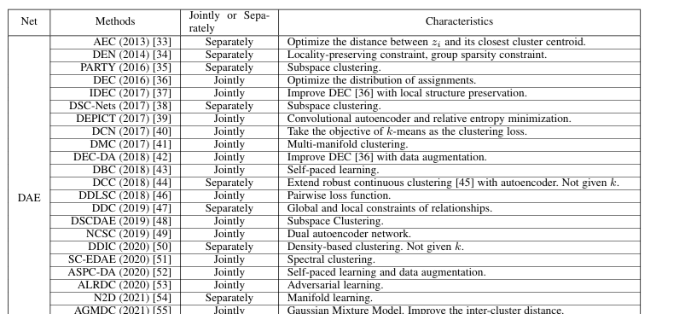

Add a similar table with the following headings

Research work (add reference and year); merits (write 2 sentence for which this work is good and relevant); Demerits (Shortcoming in the work that you intend to improve); dataset used; evaluation metrics used.

Research Gap and Research Questions
This section is very good – you just need to add few sentences on how would you solve the research questions? What will be the evaluation metrics you will be using?

References
I would suggest to add more references (15-20 would be a good number) add more references from learning representation and structure using deep learning for document clustering

